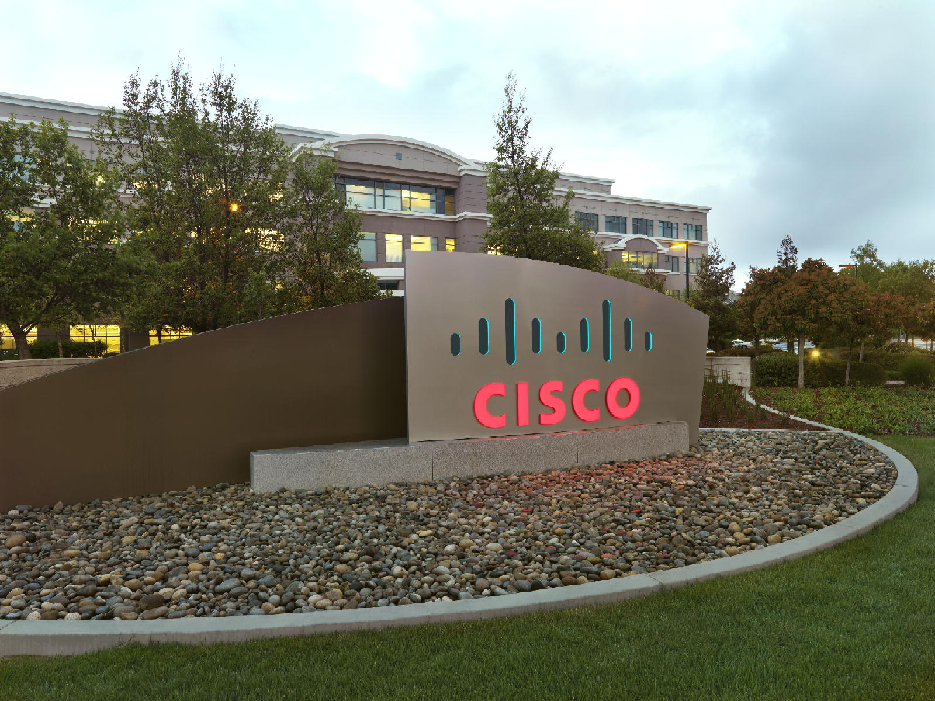

Advanced Service Assets

“PDTool” Promotion and Deployment Tool

Lab Guide
Data Virtualization Business Unit Advanced Services
March 2015

TABLE OF CONTENTS
Practice Goals 4
Supported Platforms 4
Overview 4
License 4
Pre-requisites 4
PD Tool High-level Steps 6
Assumptions 6
Procedure 7
Appendix A: Known Errors 13

Document Control

Version History
Version | Date | Author | Description
1.0 | 08/15/2012 | Mike Tinius | Initial revision
3.0 | 8/21/2013 | Mike Tinius | Updated docs to Cisco format
3.1 | 2/18/2014 | Mike Tinius | Prepare docs for open source.
3.2 | 11/17/2014 | Mike Tinius | Updated license.
3.3 | 3/4/2015 | Mike Tinius | Updated docs to Cisco format.

Related Documents
Document | Date | Author

Data Virtualization Business Unit (DVBU) Products Referenced
DVBU Product Name | Version
Composite Information Server | 6.2, 7.0

Practice Goals
We will use the Promotion and Deployment Tool for executing a command line deployment of artifacts to a local CIS 5.1, CIS 5.2 or CIS 6.0 server instance. If available a subversion VCS server will be used for checking out CIS resources and importing into the local CIS instance.

Supported Platforms
CIS 5.1, CIS 5.2, CIS 6.0, CIS 6.1 or CIS 6.2 server instance.
Subversion 1.6 or higher

Overview
The Promotion and Deployment Tool (PD Tool) is a new tool offered through Composite Professional Services engagements that gives customers an easy way of defining and executing a CIS resource promotion process. Promotion is the concept of moving CIS resources from one environment to another and then performing various configurations on the target CIS environment. Allow 2.5 hours for this lab which includes installation and configuration of PD Tool.

License
(c) 2014 Cisco and/or its affiliates. All rights reserved.
This software is released under the Eclipse Public License. The details can be found in the file LICENSE. Any dependent libraries supplied by third parties are provided under their own open source licenses as described in their own LICENSE files, generally named .LICENSE.txt. The libraries supplied by Cisco as part of the Composite Information Server/Cisco Data Virtualization Server, particularly csadmin-XXXX.jar, csarchive-XXXX.jar, csbase-XXXX.jar, csclient-XXXX.jar, cscommon-XXXX.jar, csext-XXXX.jar, csjdbc-XXXX.jar, csserverutil-XXXX.jar, csserver-XXXX.jar, cswebapi-XXXX.jar, and customproc-XXXX.jar (where -XXXX is an optional version number) are provided as a convenience, but are covered under the licensing for the Composite Information Server/Cisco Data Virtualization Server. They cannot be used in any way except through a valid license for that product.
This software is released AS-IS!. Support for this software is not covered by standard maintenance agreements with Cisco. Any support for this software by Cisco would be covered by paid consulting agreements, and would be billable work.

Pre-requisites
- Write down your assigned Student Number “NN”: _____________ (e.g. 01 – 10)
  - This number will be used to refer the car file the student will import as well as various references to “NN” within the lab procedure steps.
- Composite Topologies supported in this lab
  - Local: CIS Studio and Server installed
  - Multi-user: Local Studio and Central Development Server installed
- Composite examples “/shared/examples” must exist.
- For one section of the lab, a Version Control System (Subversion) server must exist. If one is not available, an alternate approach of importing CAR files can be used.
  - A VCS client such as subversion must be installed on the computer where the lab will be performed. TortoiseSVN 1.7.1 or higher may be used if the command line client is installed. Previous versions did not have a command line client and thus could not be used.
- Install the Promotion and Deployment Tool
  - Follow the instructions in “Composite PS Promotion and Deployment Tool Installation Guide v1.0.pdf” to install the PD Tool.
- Configure VCS Module [optional – based on VCS server availability]
  - Follow the instructions in “Composite PS Promotion and Deployment Tool Module - Version Control System.pdf” to configure VCS for PD Tool.
  - Go to the section titled “Configuring Version Control for PD Tool”.
  - If you are running a “Multi-User/Central Dev Server” topology make sure the deploy.properties has the property set to true: VCS_MULTI_USER_TOPOLOGY=true.
  - Make sure you execute the VCS Workspace Initialization command or your lab will not work properly or the Forced Checkin in Step 3 will not work.

PD Tool High-level Steps
The following high-level steps provide a road-map for the student as to what they will accomplish in this lab.
Modify Server XML File
Import Lab Resources
Perform VCS Forced Check-in
Generate XML Property Files
Create Lab Deployment Plan
Modify Module XML Property Files
Execute Deployment Plan
1
2
3
4
5
6
7
Verify Deployment Results
8

Lab Deployment Plan Steps

The following deployment plan shall be implemented as steps and actions within the orchestration property file

- VCS Check Out from or Package Export if subversion not available
  - /services/databases/TESTNN
  - /services/webservices/test/testWebServiceNN
  - /shared/testNN
- Create or Update Groups
  - group1
  - group2
- Create or Update Users
  - user1
  - user2
- Update Data Source
  - XML File
  - Database
  - Web Service
- Update Privileges
  - /shared/testNN

Assumptions
- Any references to “Location: PDTool/” within the procedure steps will be assumed that the student understands how to use Windows Explorer or a Command Line Window to navigate to the location of PDTool and the path specified within “Location:”.

- Starting with the 2012-08-15 release, the default folder for CIS 6.1 and lower is called “PDTool61” and “PDTool62” for CIS 6.2. Any reference to the location “PDTool” should be inferred as a substitution to the above stated location rule.

Procedure
1 Modify the servers.xml property file [5 min]
Background: The servers.xml file contains the connection information to the Composite Information Server (CIS). It needs to be updated before any other steps can be completed.
Location: PDTool/resources/modules
- Open servers.xml in a text editor
- Modify the id: “labhost” to match your environment (port, user, password, cishome)
- Save and close
- If the password was modified to clear text then run this utility
- Open a command line window and change directories to PDTool/bin
  - Execute:
ExecutePDTool.bat -encrypt ..\resources\modules\servers.xml
  - Notice how the clear text passwords were changed to Encrypted: passwords
- Leave the command window open. You will be using it again.
2 Execute LabPD-Deploy.dp to perform a package import [10 min]
Background: Package import allows the student to import the specific CIS resources that will be used by this lab.
Location: PDTool/resources/plans
- Modify LabPD-Deploy.dp
  - Uncomment the pkg_import line.
  - Modify "test00" to use your student number "testNN
  - Everything else should be commented out.
  - Please note how the variable $LAB_SERVERID is being used to indicate the serverId in the servers.xml file. This variable is set in deploy.properties as LAB_SERVERID=labhost. The variable is resolved upon execution. The reason for using variables is that it provides the user a “single” place to make a change so that all actions are performed against that designated server identifier. If a variable is not used, then the user would have to change all entries in the deployment orchestration property file. This is a good best practice going forward.
- Use the command line window opened in Step 1 at PDTool/bin
  - Execute:
ExecutePDTool.bat -exec ..\resources\plans\LabPD-Deploy.dp
  - Note: You may receive the error shown in Appendix A: Known Errors.
- Open Composite Studio and verify the following were imported:
  - NN is your student number
  - Databases: TESTNN
  - Web Services: testWebServiceNN
  - Folder: /shared/testNN
- Using Studio, modify testWebService URL
  - Open /shared/testNN/DataSources/testWebService
    - Provide the proper Port in the URL:
      - http://localhost:9400/services/testWebServiceNN?wsdl
    - Provide the proper User/Password for your environment.
- Leave Studio open. You will be using it again.
3 Execute LabPD-Deploy.dp to perform a VCS Forced Checkin [20 min]
Background: Check in the student’s CIS resources to the VCS server.
Assumptions: The student has configured deploy.properties for the proper VCS communication as per instructions found in the pre-requisites.
Location: PDTool/resources/plans
- Edit LabPD-Deploy.dp
  - Comment out the pkg_import line
  - Uncomment the three vcsForcedCheckins lines
- Edit PDTool/resources/modules/lab/LabVCSModule.xml
  - Modify references to 00 and change to NN (the student’s number).
  - <resourcePath>/services/databases/TEST00</resourcePath>
  - <resourcePath>/services/webservices/testWebService00</resourcePath>
  - <resourcePath>/shared/test00</resourcePath>
- Use the command line window opened in Step 1 at PDTool/bin
  - Execute:
ExecutePDTool.bat -exec ..\resources\plans\LabPD-Deploy.dp
- Verify that all three lines executed successfully (PASS) by reviewing the console output or app.log.
- Comment out the three vcsForcedCheckin lines
4 Execute the deployment orchestration property file to “Generate XML” property files [5 min]
Background: Generate the property files for the various modules as a starting point.
Location: PDTool/resources/plans
- Edit PDTool/resources/plans/LabPD-Generate.dp generation process
  - Modify all references to “00” and change to your student number “NN”
- Use the command line window opened in Step 1 at PDTool/bin
  - Execute:
ExecutePDTool.bat -exec ..\resources\plans\LabPD-Generate.dp
- Review the files generated in PDTool/resources/modules/lab
  - getLabGroupModule.xml
  - getLabUserModule.xml
  - getLabDataSourceModule.xml
  - getLabPrivilegeModule1.xml
5 Create a deployment orchestration plan file to “Execute” the deployment plan [10 min]
Location: PDTool/resources/plans
- Edit LabPD-Deploy.dp
- Comment out the pkg_import line if it is not already done.
- Comment out the three vcsForcedCheckin lines if they are not already done.
- Copy this orchestration process to the LabPD-Deploy.dp file
  - Caution: After pasting the lines in the property file, each execution line will be broken up into 2 lines. Please rejoin the lines so that the execution line is all on a single line otherwise you will get “wrong number of arguments” errors.
# Checkout resources from VCS
PASS TRUE ExecuteAction vcsCheckouts $LAB_SERVERID "testDB,testWS,testNN" "$MODULE_HOME/lab/LabVCSModule.xml" "$MODULE_HOME/servers.xml"
#
# Create or Update groups
PASS TRUE ExecuteAction createOrUpdateGroups $LAB_SERVERID "group1,group2" "$MODULE_HOME/lab/LabGroupModule.xml" "$MODULE_HOME/servers.xml"
#
# Create or Update users
PASS TRUE ExecuteAction createOrUpdateUsers $LAB_SERVERID "user1,user2" "$MODULE_HOME/lab/LabUserModule.xml" "$MODULE_HOME/servers.xml"
#
# Update Datasource
PASS TRUE ExecuteAction updateDataSources $LAB_SERVERID "ds1,ds2,ds3" "$MODULE_HOME/lab/LabDataSourceModule.xml" "$MODULE_HOME/servers.xml"
#
# Update Privileges
PASS TRUE ExecuteAction updatePrivileges $LAB_SERVERID "priv1" "$MODULE_HOME/lab/LabPrivilegeModule.xml" "$MODULE_HOME/servers.xml"
6 Modify the Module XML property files [20 min]
Location: PDTool/resources/modules/lab
- Review the existing LabGroupModule.xml [NO CHANGES]
  - This step will not use the generated file “getLabGroupModule.xml”
  - The following groups will get created or updated:
    - group1 and group2
  - Group 1 access rights:
    - privilege: ACCESS_TOOLS
  - Group 2 access rights:
    - privilege: ACCESS_TOOLS MODIFY_ALL_CONFIG MODIFY_ALL_RESOURCES MODIFY_ALL_STATUS MODIFY_ALL_USERS READ_ALL_CONFIG READ_ALL_RESOURCES READ_ALL_STATUS READ_ALL_USERS
- Review the existing LabUserModule.xml [NO CHANGES]
  - This step will not use the generated file “getLabUserModule.xml”
  - The following users will get created or updated:
    - user1 and user2
    - encryptedPassword: password
- Edit the existing LabVCSModule.xml
  - Rename all references of “00” to your student number “NN”
    - /services/databases/TEST00
    - /services/webservices/testWebService00
    - /shared/test00
- Rename getLabDataSourceModule.xml to LabDataSourceModule.xml
- Edit LabDataSourceModule.xml
  - Tweak the properties for the file entry - /shared/testNN/DataSources/ServerAttributeDefinitions
    - id:ds1
    - Make sure the value for the generic attribute <name>root</name> matches your location
      - <value> $PROJECT_HOME/PDTool/resources/modules/generated</value>
      - Note: Use forward slashes
      - Note: $PROJECT_HOME gets resolved at the time of execution. PROJECT_HOME is a Java environment variable that gets set with ExecutePDTool.bat or .sh.
  - Tweak the properties for the database entry - /shared/testNN/DataSources/ds_orders
    - id:ds2
    - Make sure the values match your environment for port
    - The encrypted password for the user tutorial is tutorial
    - Modify the generic attribute connPoolMaxSize=110
  - Tweak the properties for the web service entry - /shared/testNN/DataSources/testWebService
    - id:ds3
    - Make sure the values for login, password and url are set appropriately for your environment. Check the port number is correct also.
      - login=user2
      - password=password
      - url=http://localhost:9400/services/testWebServiceNN?wsdl
- Rename getLabPrivilegeModule1.xml to LabPrivilegeModule.xml
- Edit LabPrivilegeModule.xml,
  - Verify “priv1” /services/webservices/testWebServiceNN has your “NN” student number.
  - For all privileges (priv1) replace all <privilege> entries with the following:
<privilege>
<name>group1</name>
<nameType>GROUP</nameType>
<domain>composite</domain>
<privileges>NONE</privileges>
</privilege>
<privilege>
<name>group2</name>
<nameType>GROUP</nameType>
<domain>composite</domain>
<privileges>WRITE EXECUTE SELECT</privileges>
</privilege>
7 Execute the deployment solution [20 min]
- Prepare to execute by deleting artifacts in Studio
  - Open Studio and delete the folders for your student number “NN”.
    - Databases: /TESTNN
    - Web Services: /services/webservices/testWebServiceNN
    - Folder: /shared/testNN
- Use the command line window opened in Step 1 at PDTool/bin
  - Execution Hint:
    - An easy to debug the process is to comment lines of execution so that it makes it easier to focus on one issue at a time.
    - Start with 1 item, get it working and then move on the next. When all items are working individually, uncomment all action lines and run the entire process.
  - Execute:
ExecutePDTool.bat -exec ..\resources\plans\LabPD-Deploy.dp
- Review the log files:
Location: PDTool/logs
  - PDTool/logs/summary.log
  - PDTool/logs/app.log
- Known Error:
  - When the VCS Module does an import of the checked out resource, it re-introspects the data sources which may throw the error in Appendix A.
8 Validate the deployment solution [15 min]
- Use Composite Studio and Composite Manager (browser) to validate
- Validate the following exist using Studio for your student number “NN”:
  - Databases: /TESTNN
  - Web Services: /services/webservices/testWebServiceNN
  - Folder: /shared/testNN
- Validate the users exist with the correct group membership using the web-based Manager
- Validate the groups exist with the correct privileges using the web-based Manager
- Validate the data source attributes are set correctly using Studio
- Validate the privileges are set correctly using Studio
  - Right click on the folders specified above.
  - Group1: No privileges are checked
  - Group2: All privileges are checked (Read, Write, Execute, Select, Update, Insert, Delete, Grant)
- Execute the testWebService using user1/password to log in.
  - Right-click on testWebServiceNN and select “Test Web Service”
  - Use testprocsimple(‘abc’,0)
  - This should fail with insufficient privileges “401 Unauthorized”
  - Close the browser window
- Execute the testWebService using user2/password to log in.
  - Use testprocsimple(‘abc’,0)
  - This should execute successfully
<ns1:testprocsimpleResponse xmlns:ns1="com.compositesw/services/webservices/testWebService/testService">
<ns1:error xsi:nil="true"/>
</ns1:testprocsimpleResponse>

Appendix A: Known Errors
Note: When reading this error, replace any reference to “00” with your lab number “nn”.
Cause: Reintrospection failed for datasource "/shared/test00/DataSources/testWebService".
Impact: Slight. The resources still get imported into CIS. The only impact is that this web service won’t be executable until it is fixed.
Resolution: Reintrospection failed due to incorrect port number, username or password for this data source.
Fix the port number in the string http://localhost:9400/services/testWebService01?wsdl or fix the user name (admin) or the default password for admin and save.
Complete Error:
Reintrospection failed for datasource "/shared/test00/DataSources/testWebService". Reason: <serverexception>com.compositesw.cdms.datasource.DataSourceException: Error(s) were encountered while parsing the WSDL at
"http://localhost:9400/services/testWebService01?wsdl":
com.compositesw.xml.XmlException:
Error(s) loading "http://localhost:9400/services/testWebService00?wsdl": java.io.IOException:
HTTP
401 Unauthorized. [null-1900002] [datasrc-2990004]
at com.compositesw.cdms.ds.ws.WsIntrospector.loadDefinitions(WsIntrospector.java:199)
at com.compositesw.cdms.ds.ws.WsIntrospector.introspectNode(WsIntrospector.java:115)
at com.compositesw.cdms.datasource.AbstractIntrospector.introspectAllDescendents(AbstractIntrospector.java:325)
at com.compositesw.cdms.ds.ws.WsIntrospector.reintrospectDataSource(WsIntrospector.java:106)
at com.compositesw.cdms.datasource.ReintrospectOperation.performOperation(ReintrospectOperation.java:79)
at com.compositesw.server.common.AbstractAsynchronousOperation$OperationRunnable.run(AbstractAsynchronousOperation.java:401)
at java.util.concurrent.ThreadPoolExecutor$Worker.runTask(ThreadPoolExecutor.java:885)
at java.util.concurrent.ThreadPoolExecutor$Worker.run(ThreadPoolExecutor.java:907)
at java.lang.Thread.run(Thread.java:619)
Caused by: com.compositesw.xml.XmlException: Error(s) loading "http://localhost:9400/services/testWebService00?wsdl": java.io.IOException: HTTP
401 Unauthorized. [null-1900002]
at com.compositesw.xml.wsdl.WsdlReaderJWSDLImpl.readWsdl(WsdlReaderJWSDLImpl.java:85)
at com.compositesw.cdms.ds.ws.WsIntrospector.loadDefinitions(WsIntrospector.java:197)
... 8 more
Caused by: java.io.IOException: HTTP 401 Unauthorized
at com.compositesw.common.net.URLReader.readHttpURL(URLReader.java:344)
at com.compositesw.common.net.URLReader.readURL(URLReader.java:97)
at com.compositesw.common.net.URLReader.readURL(URLReader.java:74)
at com.compositesw.xml.wsdl.WsdlReaderJWSDLImpl.readWsdl(WsdlReaderJWSDLImpl.java:83)
... 9 more
</serverexception>.


Printed in USA CXX-XXXXXX-XX 10/11
Printed in USA CXX-XXXXXX-XX 10/11

